Your Paper's Title Starts Here: Please Center
San Zhang¹, Si Li² and Wu Wang²
¹School of xxx, yyy University, Guangzhou 510000, China
²School of aaa, bbb University, Guangzhou 510000, China
Corresponding author e-mail: zzz@zzz.com

Abstract. All manuscripts must be in English, also the table and figure texts, otherwise we cannot publish your paper. Please keep a second copy of your manuscript in your office. When receiving the paper, we assume that the corresponding authors grant us the copyright to use the paper for the book or journal in question. Should authors use tables or figures from other Publications, they must ask the corresponding publishers to grant them the right to publish this material in their paper.
1. Introduction
All manuscripts must be in English, also the table and figure texts, otherwise we cannot publish your paper. Please keep a second copy of your manuscript in your office. When receiving the paper, we assume that the corresponding authors grant us the copyright to use the paper for the book or journal in question. Should authors use tables or figures from other Publications, they must ask the corresponding publishers to grant them the right to publish this material in their paper.
2. Organization of the Text
1.1. Section Headings
All manuscripts must be in English, also the table and figure texts, otherwise we cannot publish your paper. Please keep a second copy of your manuscript in your office. When receiving the paper, we assume that the corresponding authors grant us the copyright to use the paper for the book or journal in question. Should authors use tables or figures from other Publications, they must ask the corresponding publishers to grant them the right to publish this material in their paper.
c₂ = a₂ + b₂ (1)
1.2. Page Numbers
All manuscripts must be in English, also the table and figure texts, otherwise we cannot publish your paper. Please keep a second copy of your manuscript in your office. When receiving the paper, we assume that the corresponding authors grant us the copyright to use the paper for the book or journal in question. Should authors use tables or figures from other Publications, they must ask the corresponding publishers to grant them the right to publish this material in their paper.
3. Organization of the Text
All manuscripts must be in English, also the table and figure texts, otherwise we cannot publish your paper. Please keep a second copy of your manuscript in your office. When receiving the paper, we assume that the corresponding authors grant us the copyright to use the paper for the book or journal in question. Should authors use tables or figures from other Publications, they must ask the corresponding publishers to grant them the right to publish this material in their paper. As show in Fig. 1 and Table 1, three scheme comparing.
References are cited in the text just by square brackets [1]. Two or more references at a time may be put in one set of brackets [3, 4]. The references are to be numbered in the order in which they are cited in the text and are to be listed at the end of the contribution under heading references, see our example below.

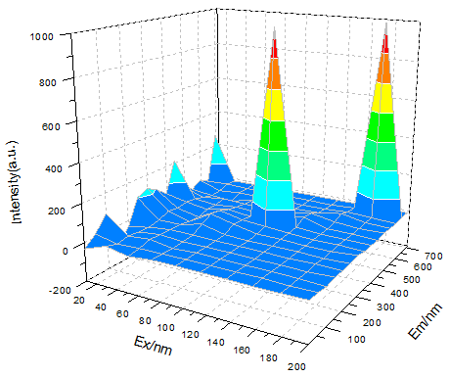
Figure 1. Two or more references.

All manuscripts must be in English, also the table and figure texts, otherwise we cannot publish your paper. Please keep a second copy of your manuscript in your office. When receiving the paper, we assume that the corresponding authors grant us the copyright to use the paper for the book or journal in question. Should authors use tables or figures from other Publications, they must ask the corresponding publishers to grant them the right to publish this material in their paper.

Table 1. Three Scheme comparing.
Numble | Scheme 1 | Scheme 2 | Scheme 3 | Scheme 4 | Scheme 5
1 | 456 | 456 | 123 | 123 | 123
2 | 789 | 213 | 644 | 644 | 644
3 | 213 | 654 | 649 | 649 | 649
- Conclusion
All manuscripts must be in English, also the table and figure texts, otherwise we cannot publish your paper. Please keep a second copy of your manuscript in your office. When receiving the paper, we assume that the corresponding authors grant us the copyright to use the paper for the book or journal in question. Should authors use tables or figures from other Publications, they must ask the corresponding publishers to grant them the right to publish this material in their paper.
Acknowledgments
This work was financially supported by xxx fund.

References
- J. van der Geer, J.A.J. Hanraads, R.A. Lupton, The art of writing a scientific article, J. Sci. Commun. 163 (2000) 51-59.
- W. Strunk Jr., E.B. White, The Elements of Style, third ed., Macmillan, New York, 1979.
- Reference to a chapter in an edited book:
- G.R. Mettam, How to prepare an electronic version of your article, in: B.S. Jones, R.Z. Smith (Eds.), Introduction to the Electronic Age, E-Publishing Inc., New York, 1999, pp. 281-304.
- R.J. Ong, J.T. Dawley and P.G. Clem: submitted to Journal of Materials Research (2003)
- P.G. Clem, M. Rodriguez, J.A. Voigt and C.S. Ashley, U.S. Patent 6,231,666. (2001)
- Information on http://www.weld.labs.gov.cn

