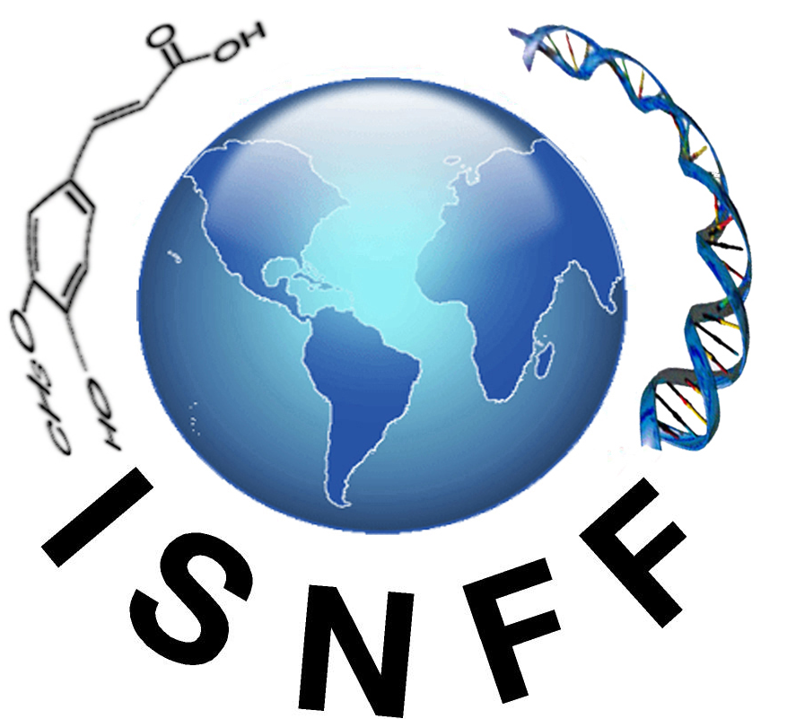
ISNFF Title and Abstract Submission

CALL FOR PRESENTATION PAPERS 2021
Platform for Foods, Nutrition and Medical Science
October 17-20, 2021
Platinum Hanjue Hotel, Nanjing, China
Abstract submission deadline July 31, 2021

I would like to attend and present: | □ Oral □ Poster □ Oral or Poster  □ Student competition  Session Name:
Title:
Abstract (150 words or less):

Key words (3-5 key words)
Authors:
(underline the presenting author):
Address:
Telephone:
E-mail(of each author, in order):

If presenting, when submitting your abstract please indicate poster/oral and indicate primary and secondary session selection.

Choice 1: _______________________________________________________________

Choice 2:________________________________________________________________

(Please submit abstract to the website: www.isnff2021.com before July 31, 2021)

Notification time of acceptance: 31st, August, 2021

