Type the Title of your Paper Here

Author nameª, Co-Author nameª, Co-Author name^{b}*
ªAffiliation, Street, City, State, Zip-code, Country
^{b}Affiliation, Street, City, State, Zip-code, Country

Abstract
A concise and factual abstract is required. The abstract should state briefly the purpose of the research, the principal results and major conclusions. The abstract is often presented separately from the article, so it must be able to stand alone. For this reason, please avoid references and non-standard or uncommon abbreviations in the abstract. The abstract should use the pre-defined font, be contained within one single paragraph, and the number of words should not exceed 200.

Keywords: risk assessment, inherent safer processes, safety culture, … (3-5 keywords)

1. Introduction
State the objectives of the work and provide an adequate background, avoiding a detailed literature survey or a summary of the results.
2. Material and methods
Provide sufficient details to allow the work to be reproduced by an independent researcher. Methods that are already published should be summarized, and indicated by a reference. If quoting directly from a previously published method, use quotation marks and also cite the source. Any modifications to existing methods should also be described.
3. Theory/calculation
A Theory section should extend, not repeat, the background to the article already dealt with in the Introduction and lay the foundation for further work. In contrast, a Calculation section represents a practical development from a theoretical basis.
4. Results
Results should be clear and concise.
4.1 Figures
For figures, the quality of labeling, line thickness and other details should be suitable for archival publication, and any photographs must be provided as glossy prints. Ensure that each illustration has a caption, which should be placed below the illustration. A caption should ideally comprise a brief title and a description of the illustration to minimize amount of text within the illustration. Number figures consecutively in accordance with their appearance in the text.
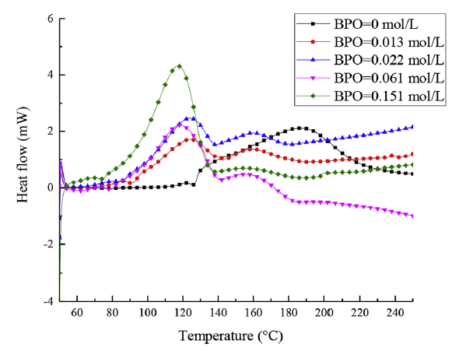
Fig. 1. Heat flow curve of styrene polymerization at different initiator concentrations by using DSC at a scanning rate of β =2 °C/min.
4.2 Tables
Number tables consecutively in accordance with their appearance in the text. Table captions should be placed above the tables. The numbers should not include the number of the section (or chapter). Place footnotes to tables immediately below the table body and indicate them with superscript lowercase letters. Be sparing in the use of tables and ensure that the data presented in tables do not duplicate results described elsewhere in the article.
Table 1 Severity grading of runaway reactions under different conditions.
Sample | ΔT_{ad}(°C) | ΔH(J/g) | Severity level
1 | 312.12 | 2130 | Catastrophic
2 | 255.30 | 1410 | Catastrophic
3 | 259.16 | 1440 | Catastrophic
4 | 311.85 | 1710 | Catastrophic
4.3 Nomenclature and units
Follow internationally accepted rules and conventions: use the international system of units (SI). If other quantities are mentioned, give their equivalent in SI. You are urged to consult IUPAC: Nomenclature of Organic Chemistry for further information.
5. Discussion
This should explore the significance of the results of the work, not repeat them. A combined Results and Discussion section is often appropriate. Avoid extensive citations and discussion of published literature.
6. Conclusions
The main conclusions of the study may be presented in a short Conclusions section, which may stand alone or form a subsection of a Discussion or Results and Discussion section.
Acknowledgments
Collate acknowledgements in a separate section at the end of the article before the references and do not, therefore, include them on the title page, as a footnote to the title or otherwise. List here those individuals who provided help during the research (e.g., providing language help, writing assistance or proof reading the article, etc.).
References
Please ensure that every reference cited in the text is also present in the reference list (and vice versa). Any references cited in the abstract must be given in full. Unpublished results and personal communications are not recommended in the reference list, but may be mentioned in the text. If these references are included in the reference list they should follow the standard reference style of the journal and should include a substitution of the publication date with either 'Unpublished results' or 'Personal communication'. Citation of a reference as 'in press' implies that the item has been accepted for publication. Some examples are provided in the following. Other details in terms of citation and references are referred to the format required by Journal of Loss Prevention in the Process Industries.
Examples:
Journal publication:
Van der Geer, J., Hanraads, J.A.J., Lupton, R.A., 2010. The art of writing a scientific article. J. Sci. Commun. 163, 51–59. https://doi.org/10.1016/j.Sc.2010.00372.
Book:
Strunk Jr., W., White, E.B., 2000. The Elements of Style, fourth ed. Longman, New York.
Chapter in an edited book:
Mettam, G.R., Adams, L.B., 2009. How to prepare an electronic version of your article, in: Jones, B.S., Smith , R.Z. (Eds.), Introduction to the Electronic Age. E-Publishing Inc., New York, pp. 281–304.
Website:
Cancer Research UK, 1975. Cancer statistics reports for the UK. http://www.cancerresearchuk.org/aboutcancer/statistics/cancerstatsreport/ (accessed 13 March 2003).
Dataset:
[dataset] Oguro, M., Imahiro, S., Saito, S., Nakashizuka, T., 2015. Mortality data for Japanese oak wilt disease and surrounding forest compositions. Mendeley Data, v1. https://doi.org/10.17632/xwj98nb39r.1.

* Corresponding author. Email address: C-author@xxxx.edu.cn

